WINDOW CONTROL PANEL TO BRING THE SPECIFIC MINIMIZED WINDOW ON TO THE SCREEN

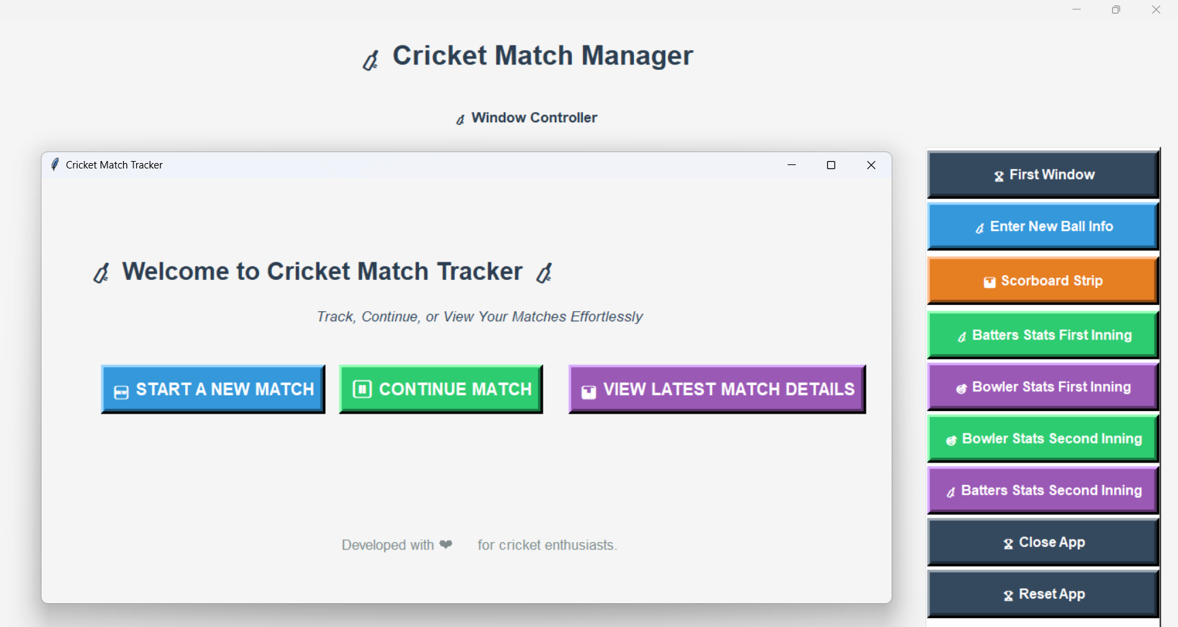

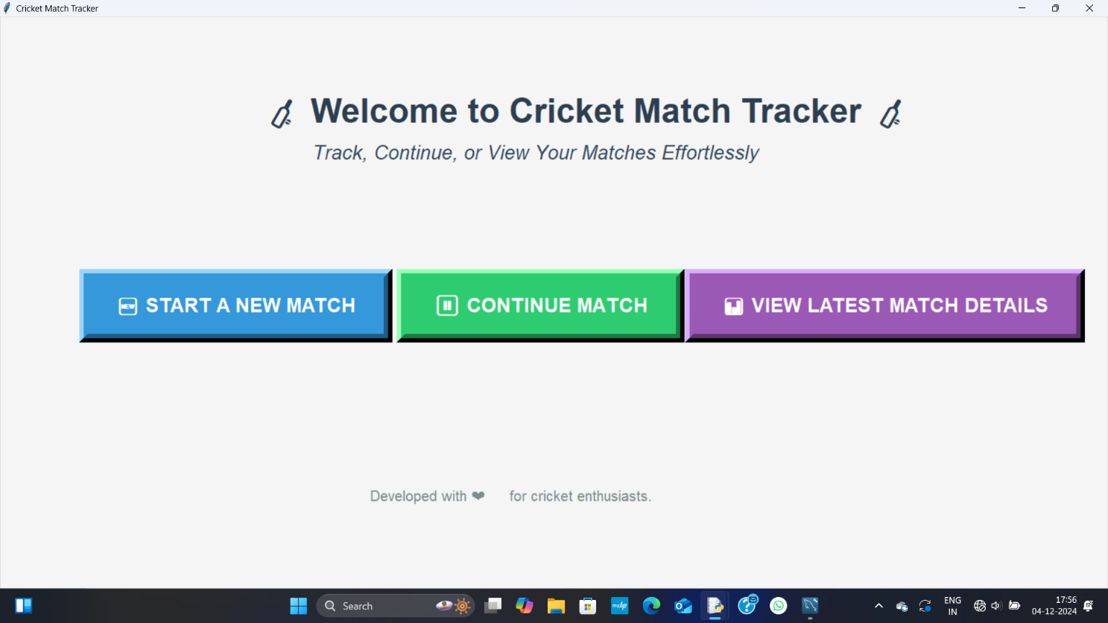
FIRST START WINDOW TO START A NEW MATCH OR CONTINUE OR SEE DETAILS OF LATEST MATCH

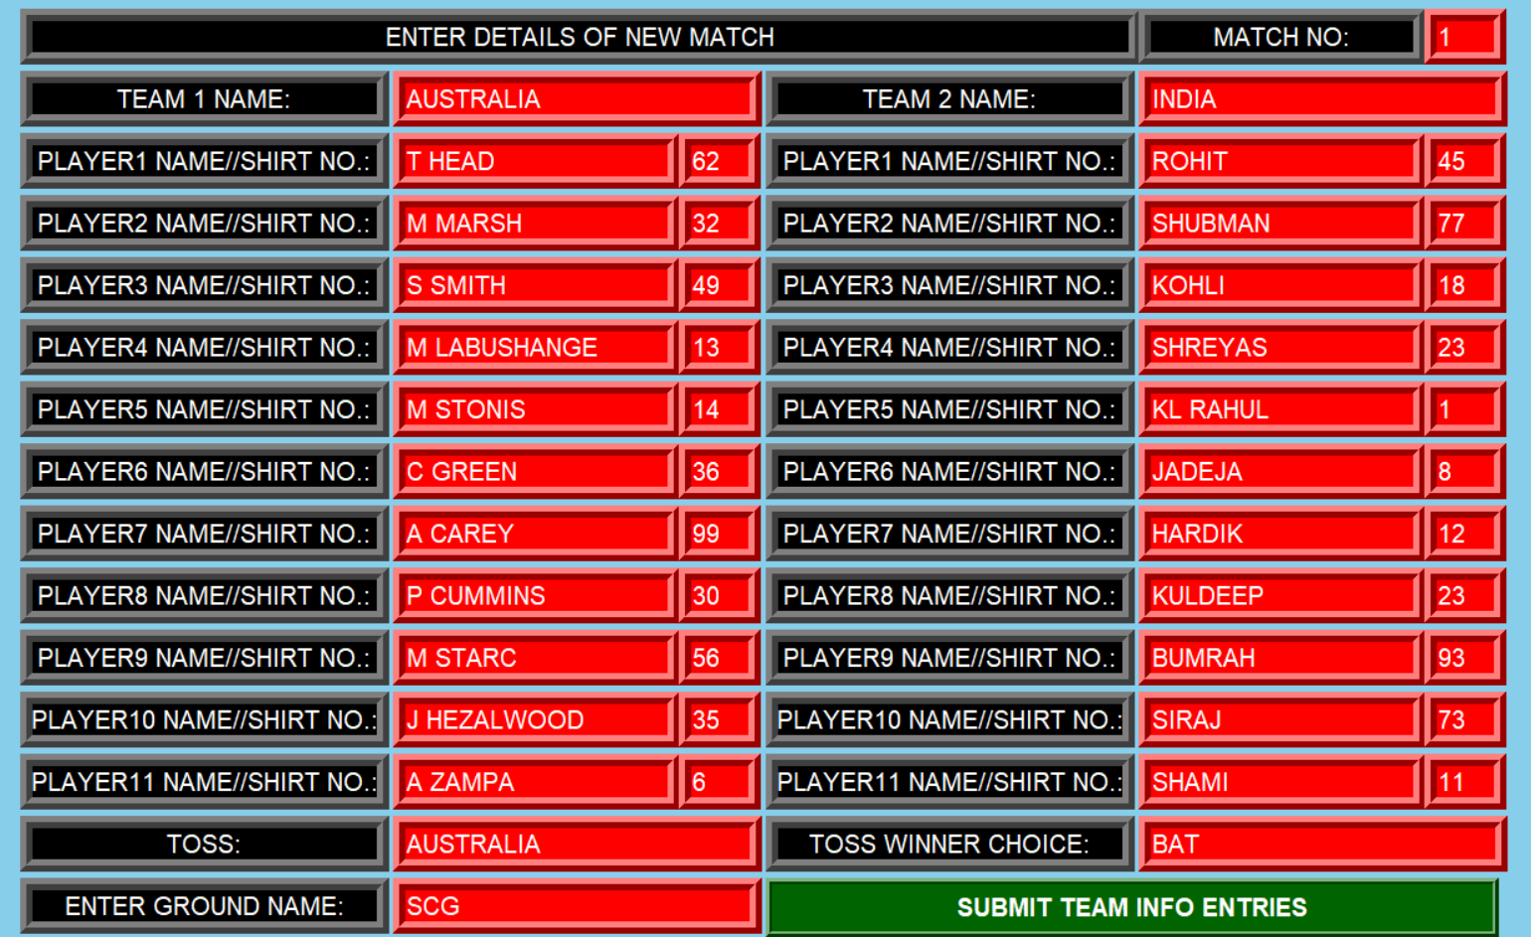
TEAM INFORMATIONS LIKE PLAYERS NAME, SHIRT NUMBERS, TOSS, GROUND, MATCH NO ARE BEING ENTERED.

ON THE WINDOW CONTROL PANEL, BALL ENTRY INFORMATION WINDOW IS BEING SHOWN, WHICH IS OPENED, JUST AFTER SUBMITING THE INFORMATIONS OF TEAMS,BOLWER STATS AND BATTER STATS BUTTONS GENERATES THEIR RESPECTIVE WINDOWS AND REFRESH BUTTON STARTS THE MATCH FROM BOWL 0 AND REMOVES THE ALL BOWLS DATA OF THAT MATCH,UPDATE BUTTON UPDATES THE DATA FOR THAT BOWL,DELETE BUTTON DELETES THE DATA FOR THAT BOWL,SUBMIT BUTTON SUBMITS THE DATA FOR THAT BOWL ENTERED IN THE ARMVALUE, FINISH BUTTON FINISHES THE MATCH AND OPEN A WINDOW TO ENTER SOME INFORMATIONS, EXIT BUTTON CLOSES THE APP.

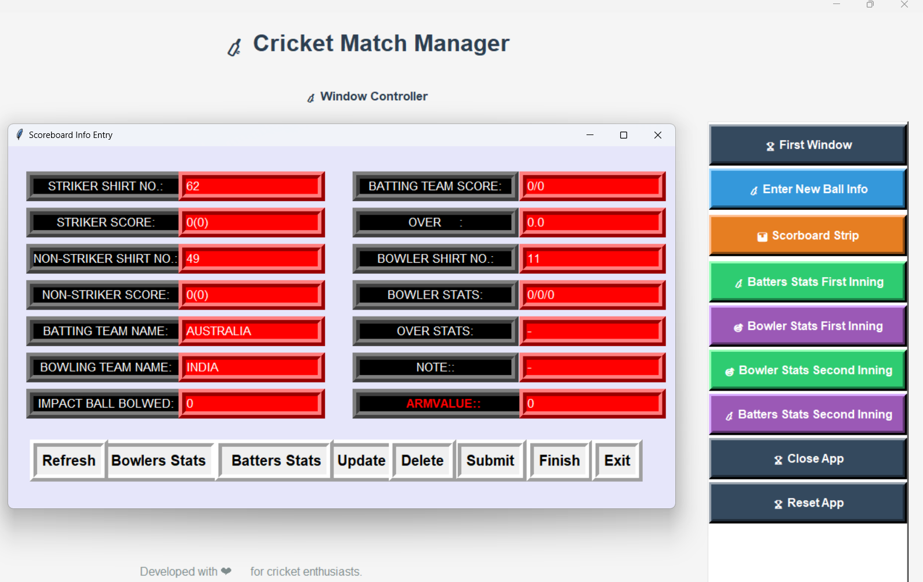

FIRST BOWL INFORMATIONS ENTERED

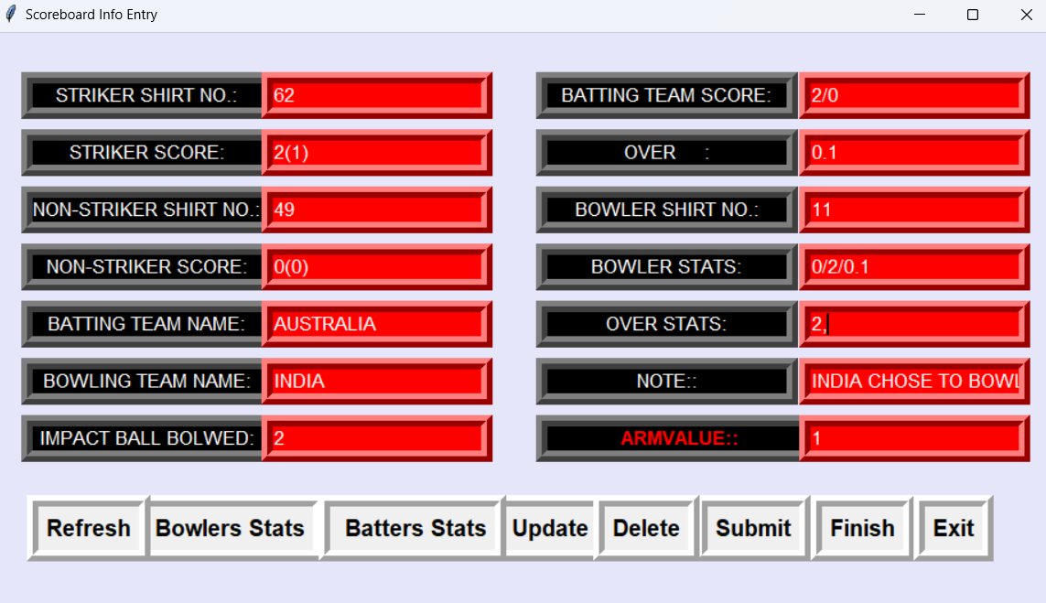

SCOREBOARD STRIP GOT GENERATED, CONTAINING INFORMATIONS OF BOWL1
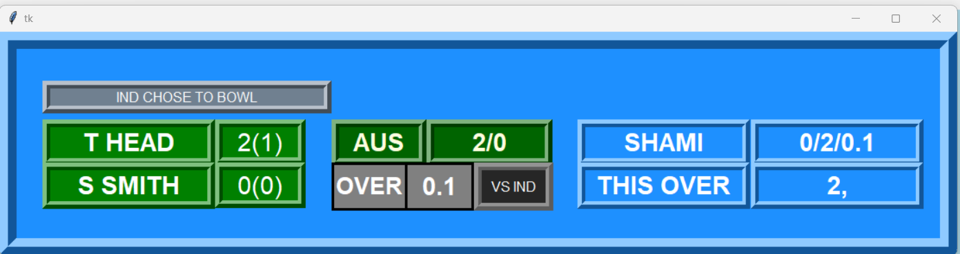

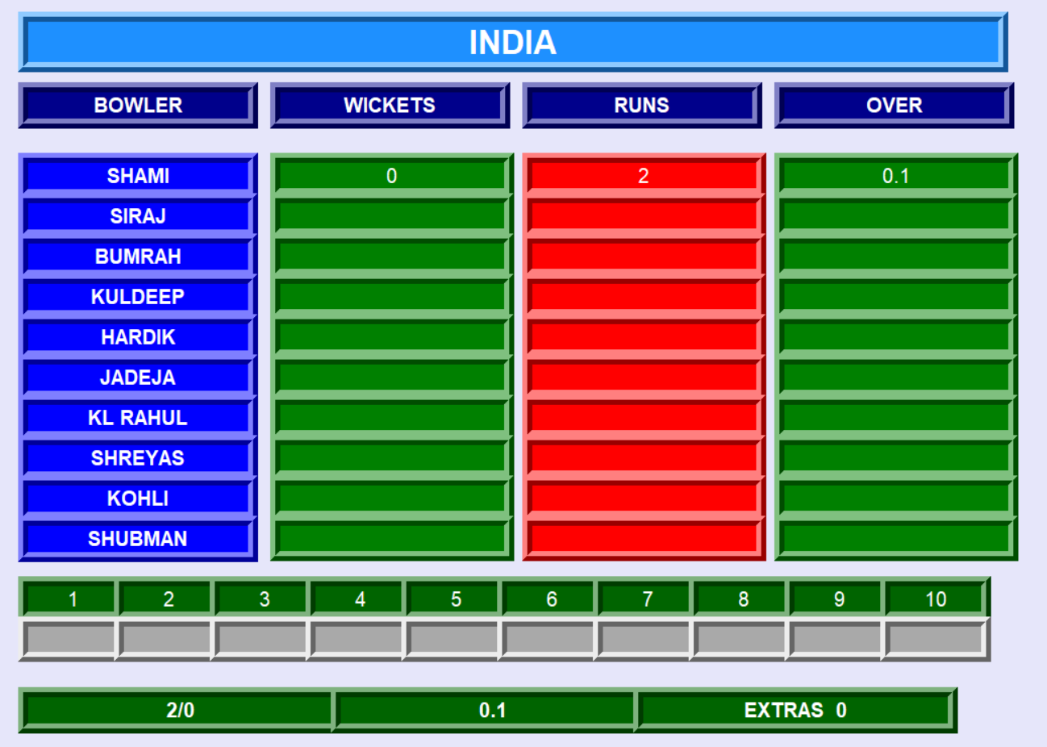
B0WLERS WINDOW IS GENERATED, CONTAINING INFORMATIONS OF FIRST BOWL
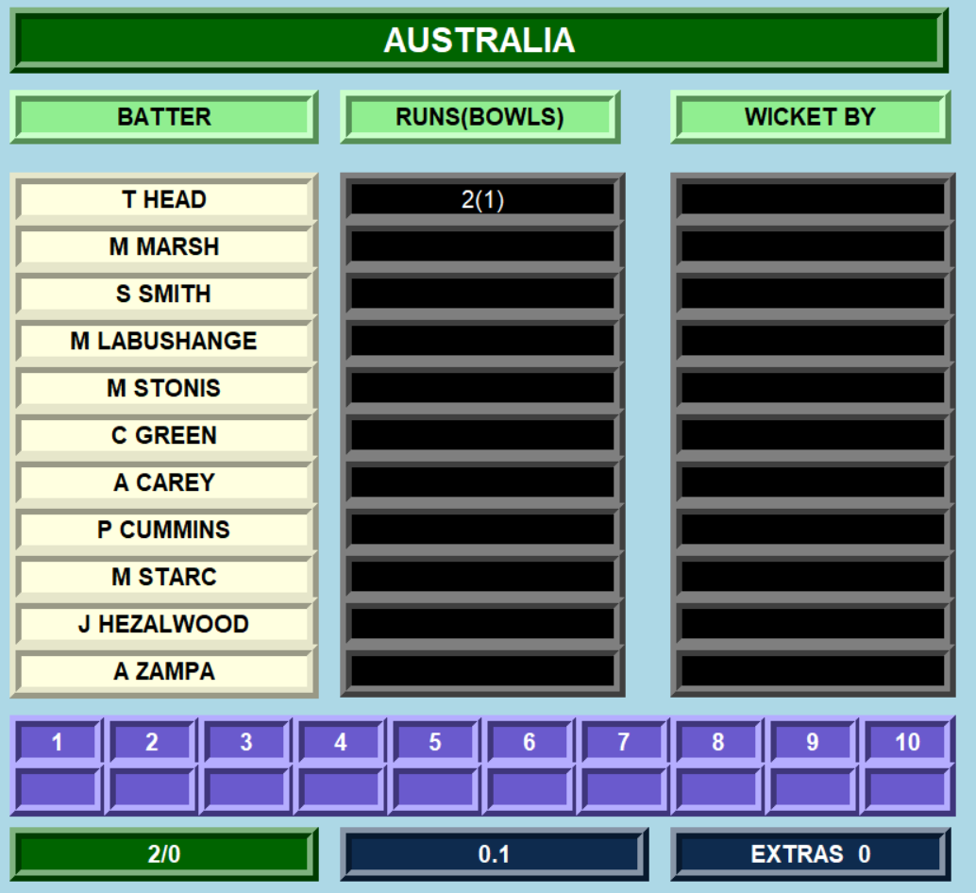
BATTERS WINDOW IS GENERATED, CONTAINING INFORMATIONS OF FIRST BOWL

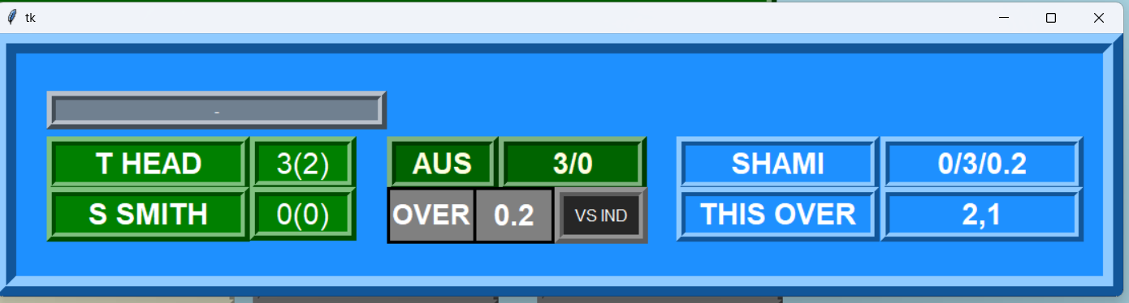
SCOREBOARD STRIP GOT CONFIGUED, CONTAINING INFORMATIONS OF BOWL 2ND

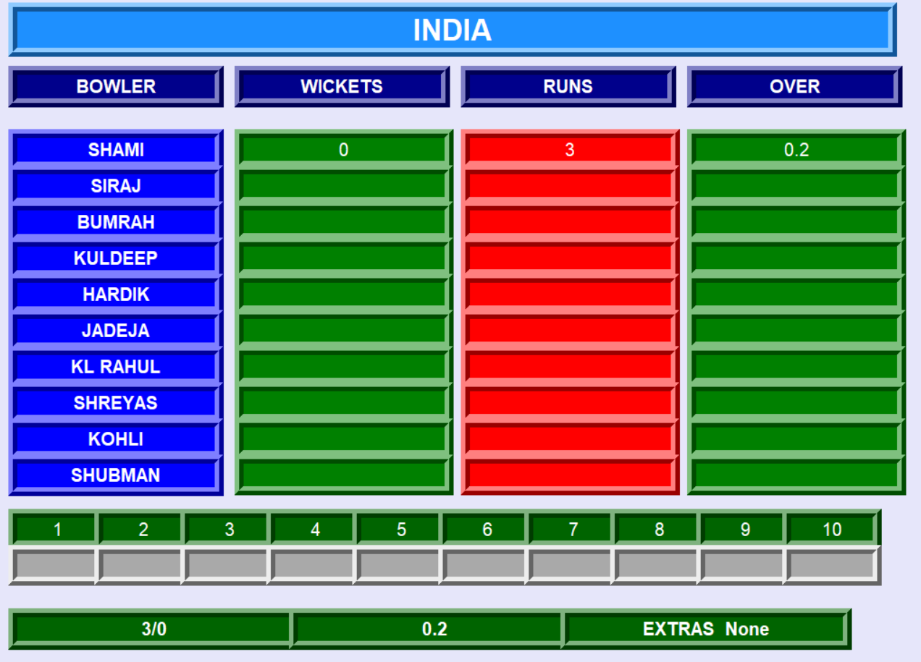
B0WLERS WINDOW IS CONFIGUED, CONTAINING INFORMATIONS OF 2ND BOWL

BATTERS WINDOW IS CONFIGUED, CONTAINING INFORMATIONS OF 2ND BOWL
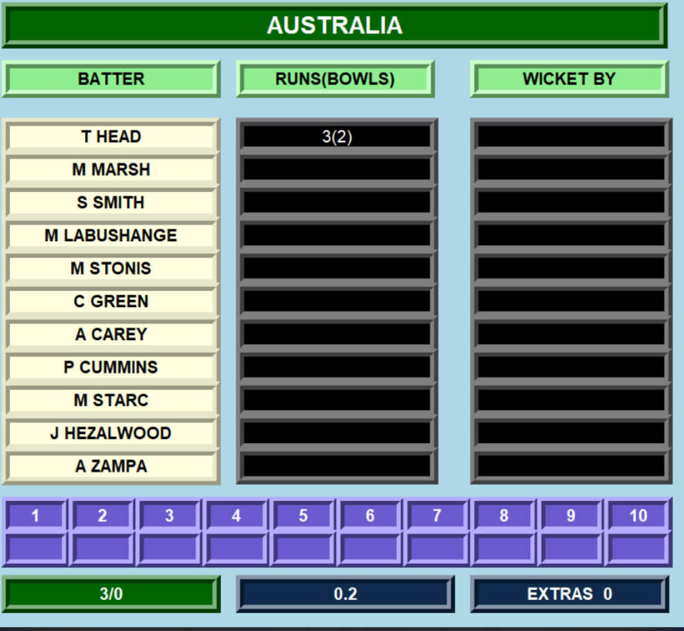

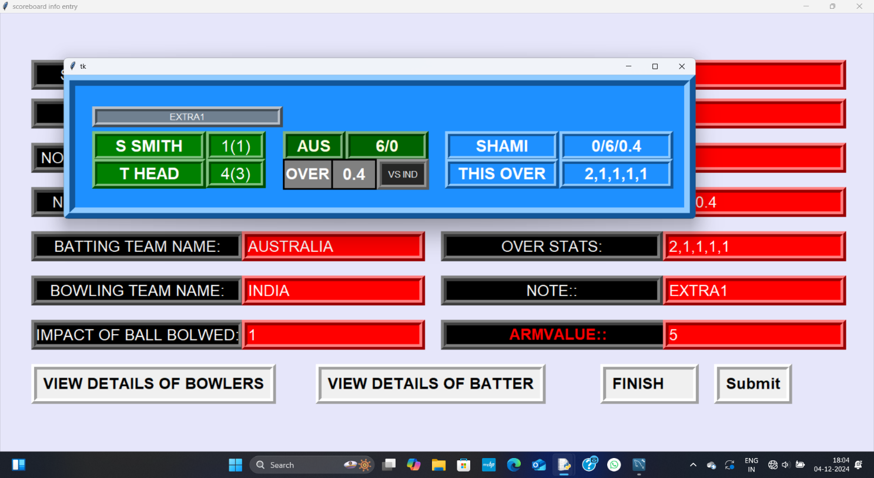
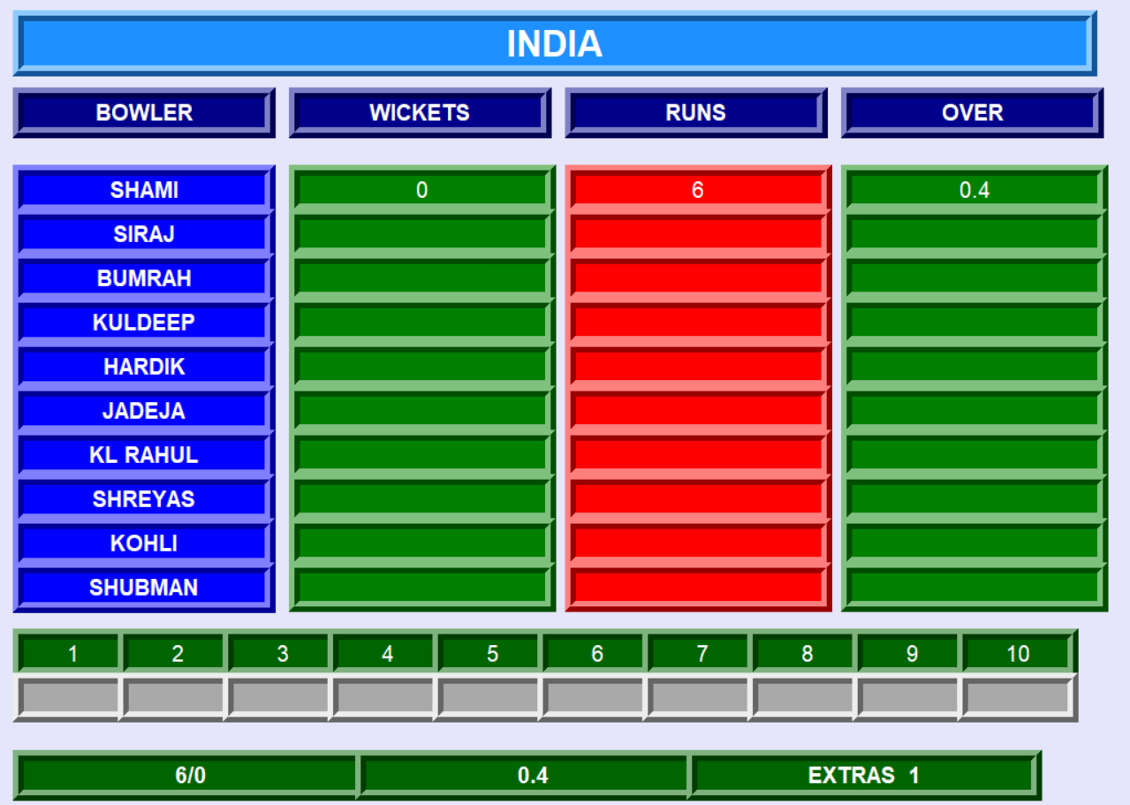
AFTER THE FOURTH BALL An EXTRA 1 RUN IS DELIVERED PROBABLY A WIDE SO IN THE NOTE SECTION IT IS MENTIONED AND IS BEING REFLECTED IN SCORECARD STRIP

IN THE BOWLERS WINDOW THE EXTRA RUN IS BEING SHOWN
IN THE BATTERS WINDOW THE EXTRA RUN IS BEING SHOWN
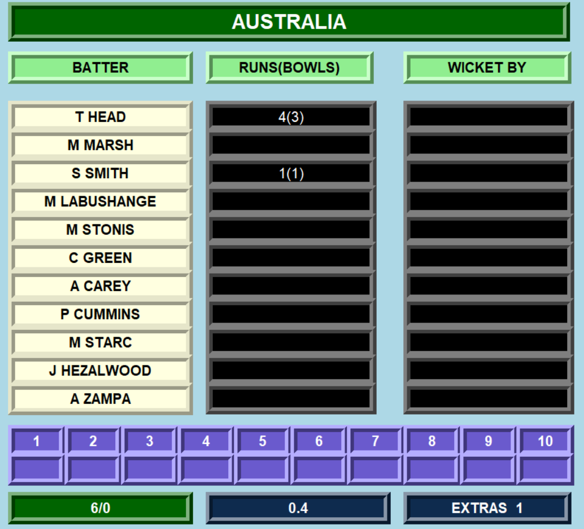

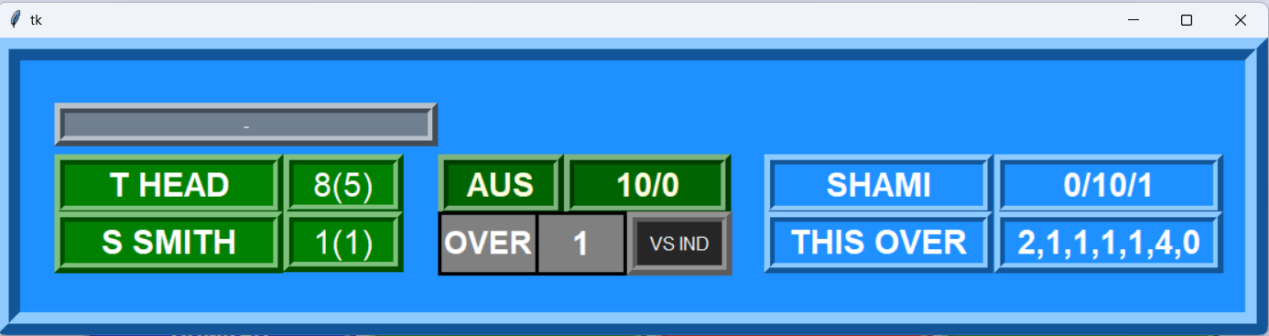
SCOREBOARD STRIP AFTER 1 OVER

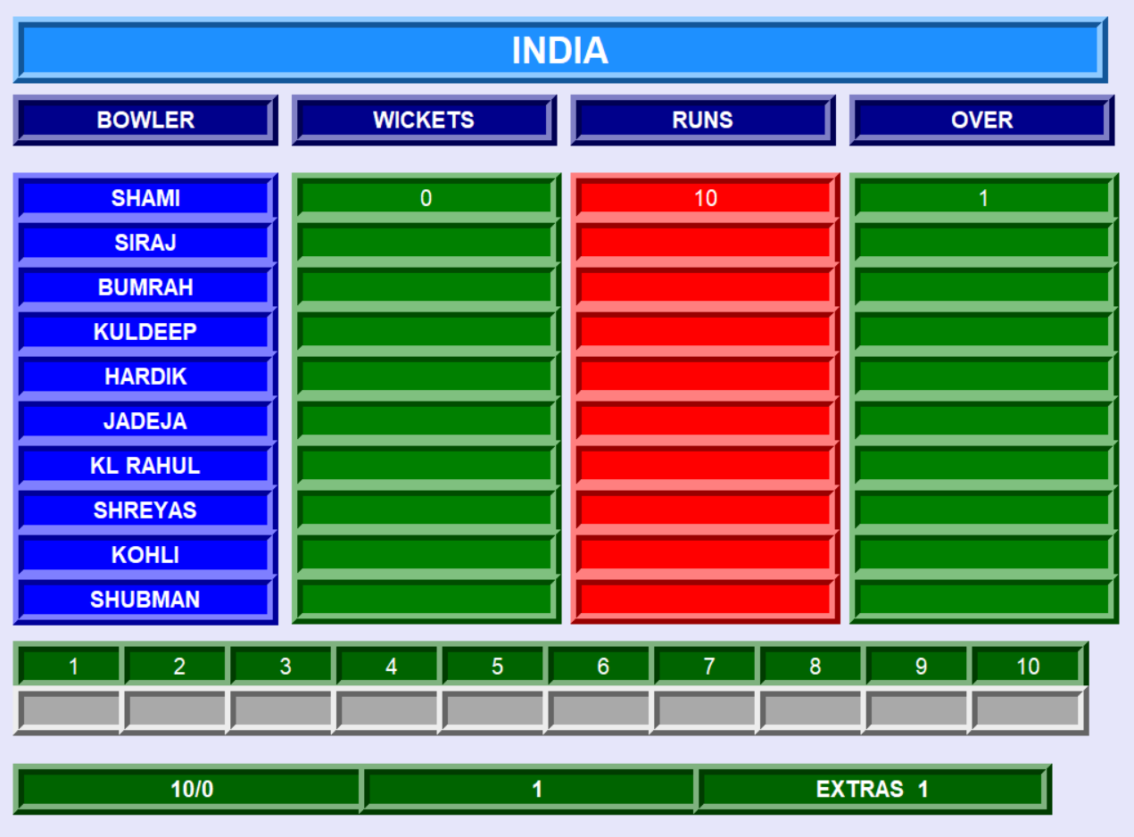
BOWLERS WINDOW AFTER 1 OVER

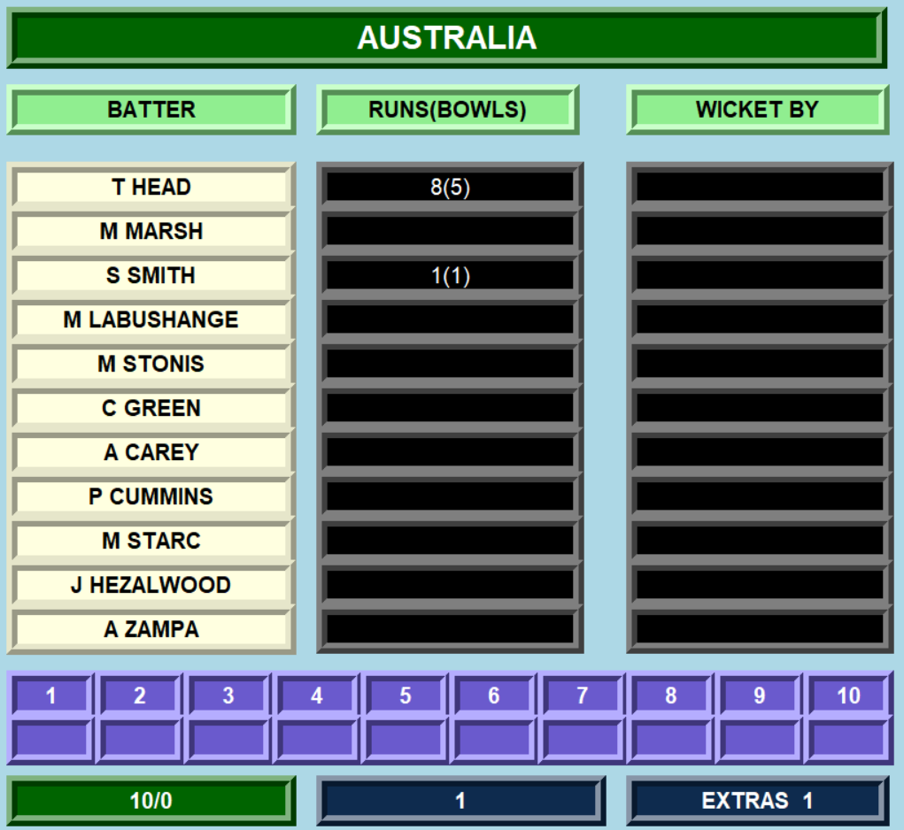
BATTERS WINDOW AFTER 1 OVER

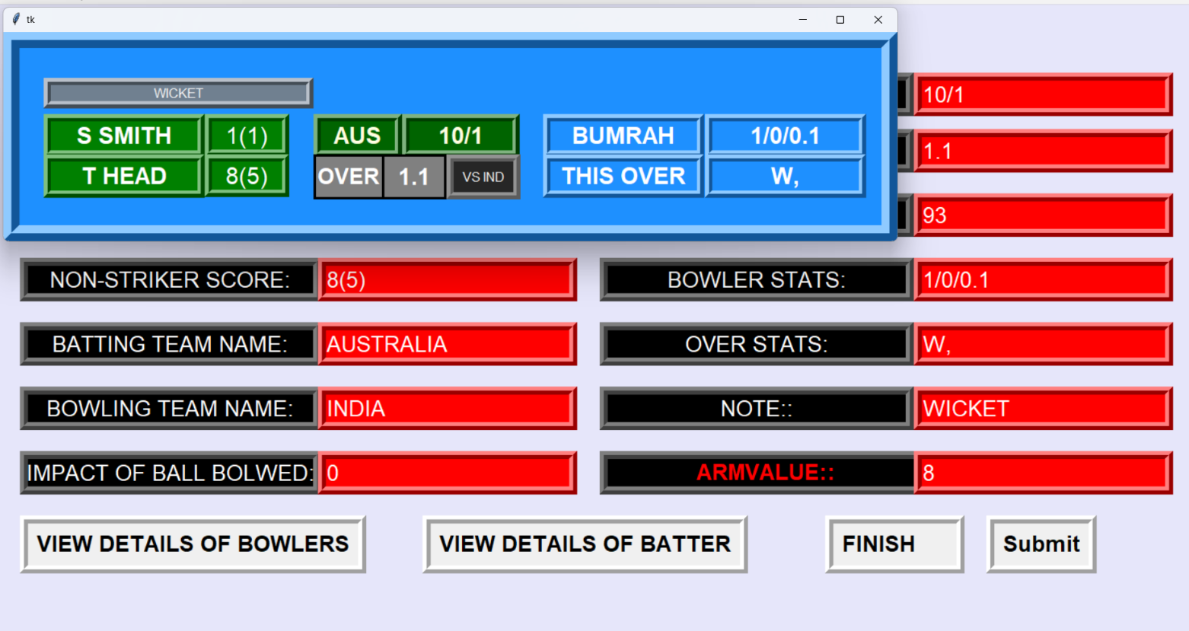
WITH THE NEW OVER, NEW BOWLER, FIRST WICKET IS DOWN, DETAILS ARE ENTERED INTO THE ENTRY WINDOW NOTE SECTION CONTAINS TERM WICKET AND IS BEING REFLECTED IN THE SCOREBOARD STRIP
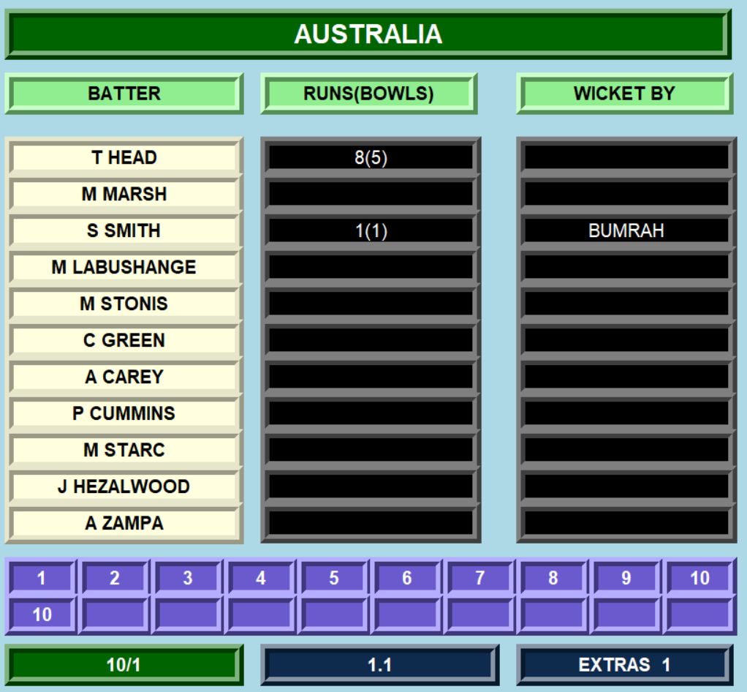

THE BATTER’S WINDOW IS UPDATED WITH WHO TOOK THE WICKET WHOSE WICKET IS DOWN AND ON WHICH RUN THE WICKET FELL OFF

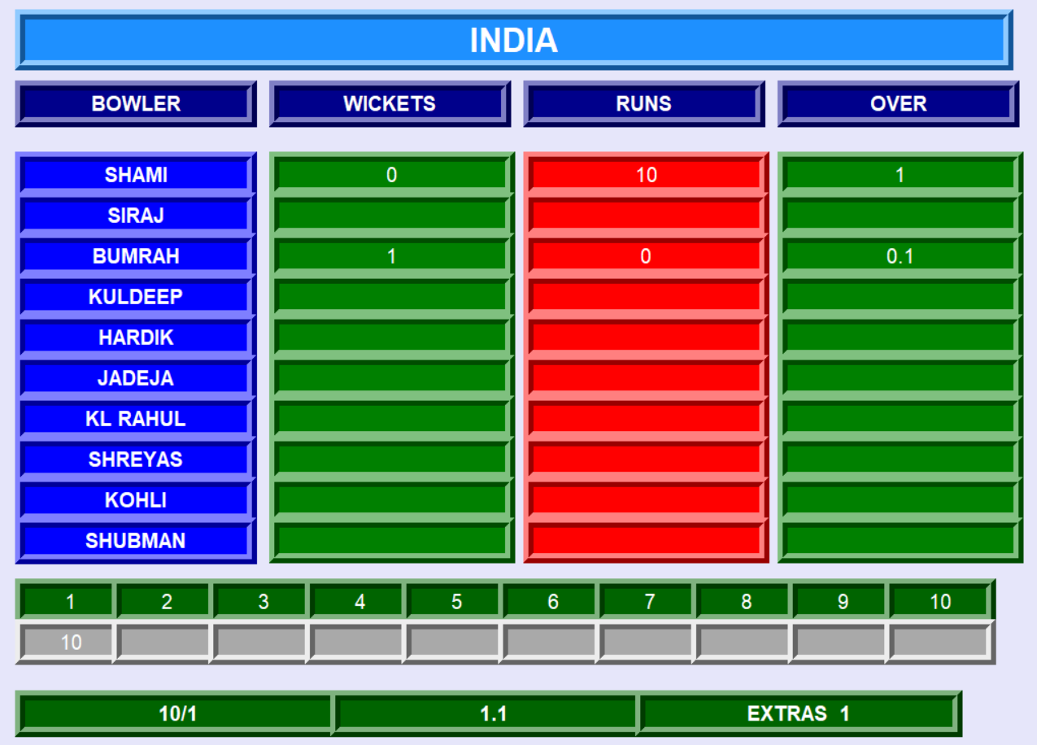

THE BOLWERS WINDOW IS UPDATED WITH THE WHICH BOLWER TOOK WICKET HIS STATS AND ON WHICH RUN THE WICKET FELL OFF

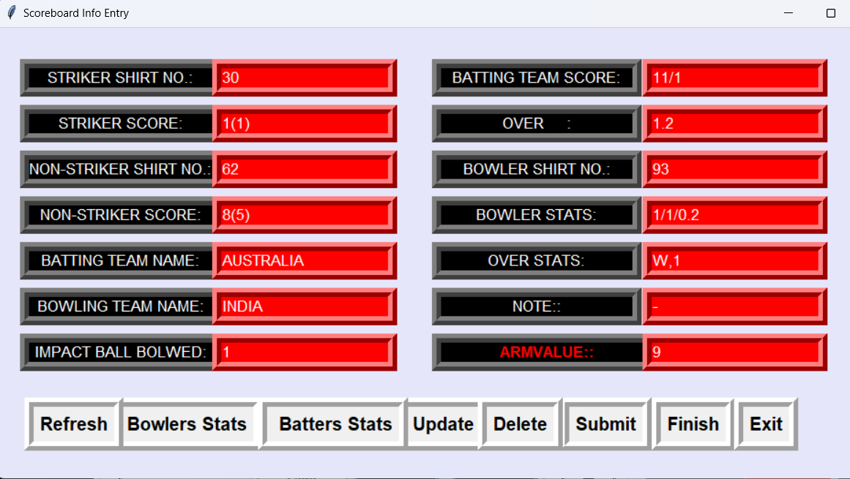
THE NEXT DELIVERY DATA IS ENTERED
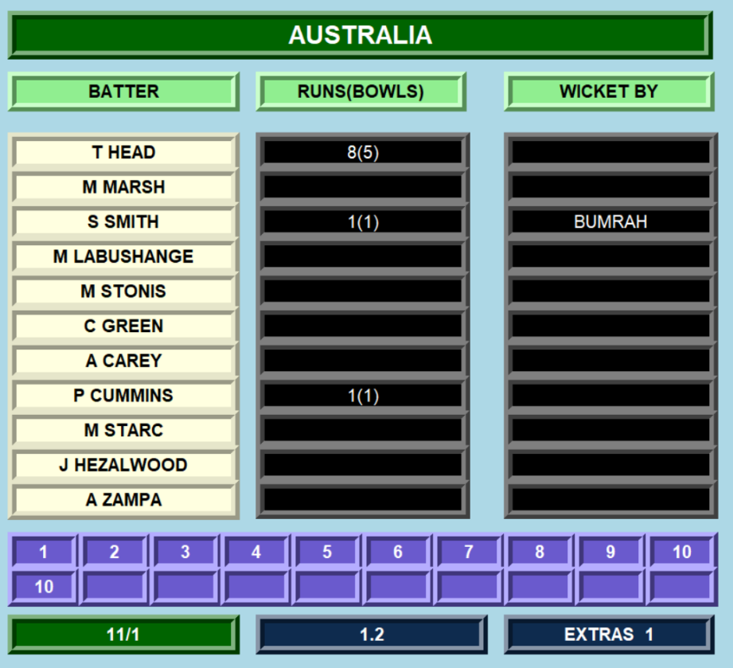
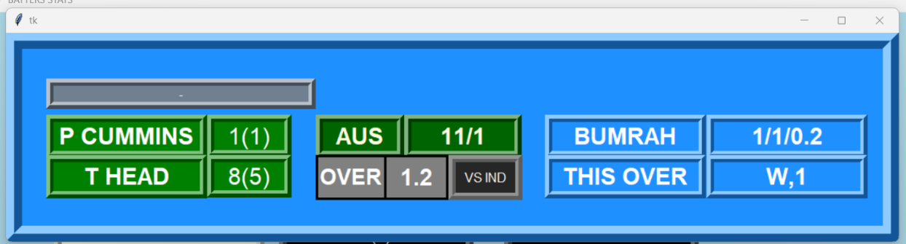
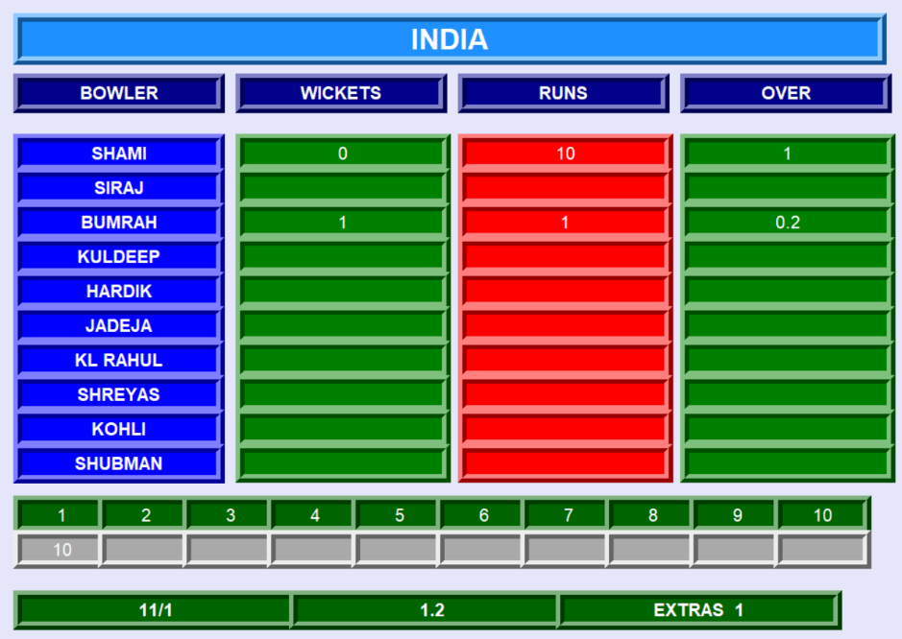
THE NEXT DELIVERY DATA IS UPDATED IN THE SCOREBOARD STRIP, IN THE BOLWERS WIDOW, IN THE BATTERS WINDOW

THE FIRST INNING LAST BOWL DATA ENTERED
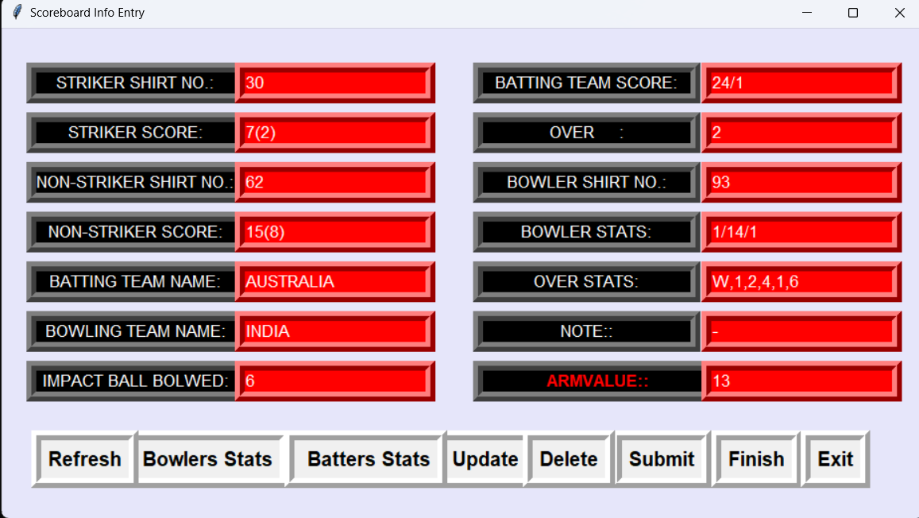
THE FIRST INNING LAST BOWL DATA UPDATED IN THE BATTER WINDOW
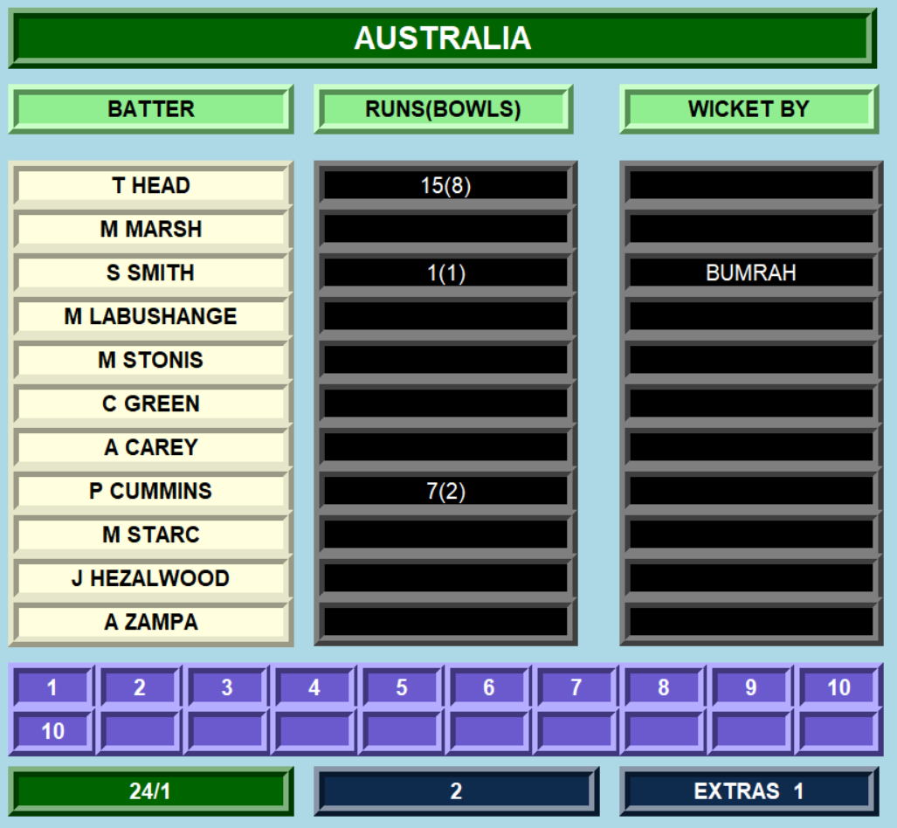

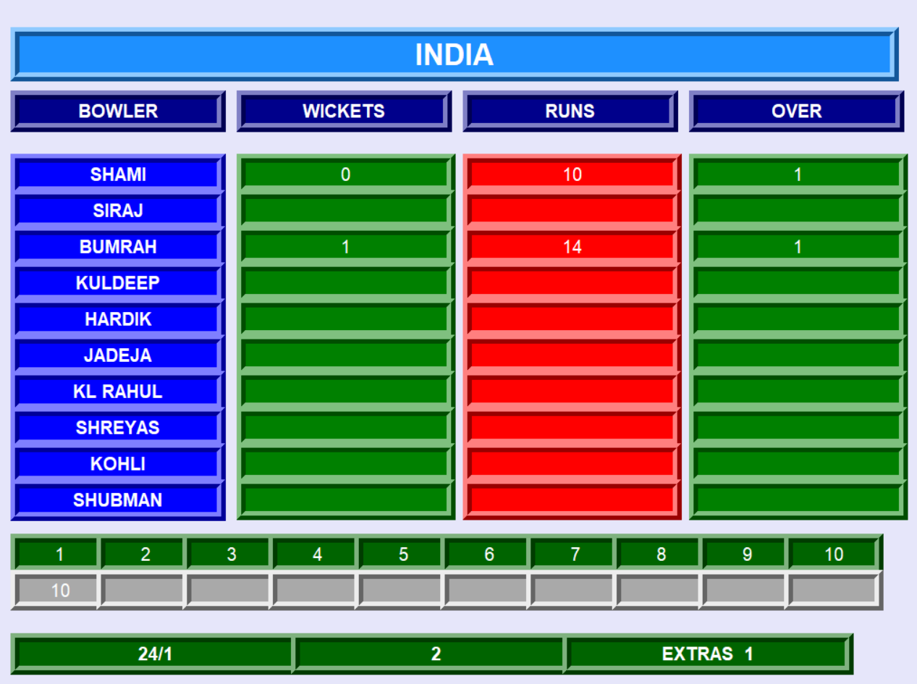
THE FIRST INNING LAST BOWL DATA UPDATED IN THE BOWLER WINDOW

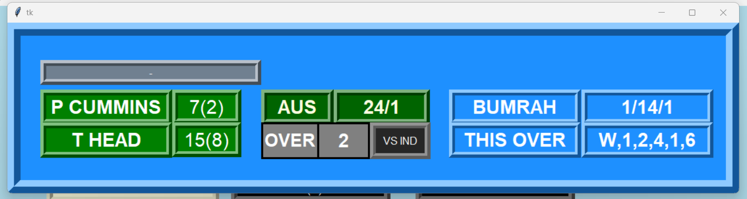
THE FIRST INNING LAST BOWL DATA UPDATED IN THE SCOREBOARD STRIP

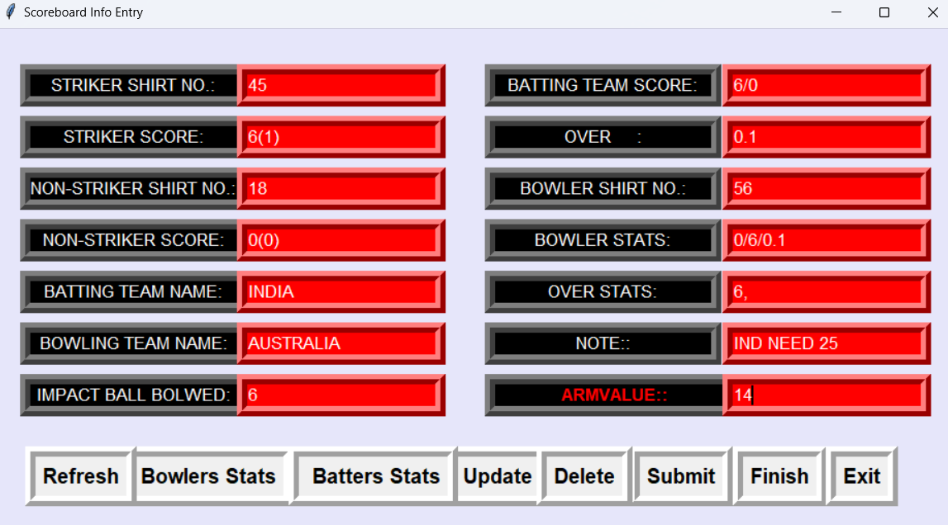
THE SECOND INNING FIRST BOWL DATA ENTERED

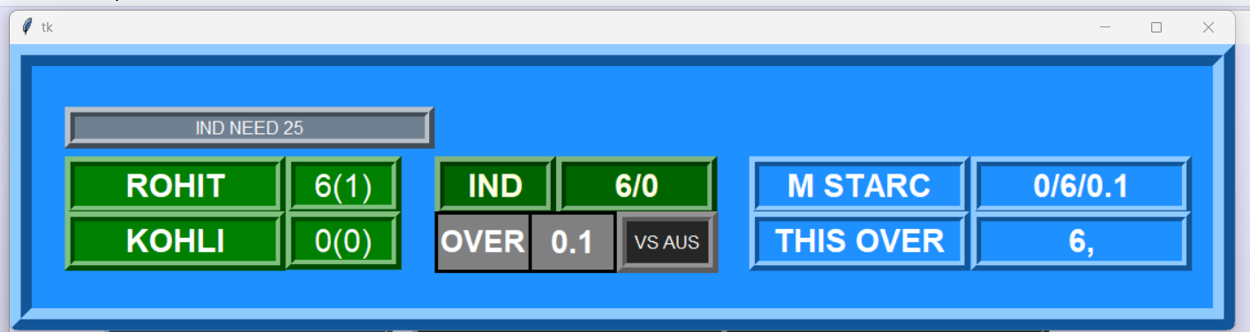
THE SECOND INNING FIRST BOWL DATA SHOWN IN SCOREBOARD STRIP

THE SECOND INNING FIRST BOWL DATA SHOWN IN THE BOWLERS WINDOW
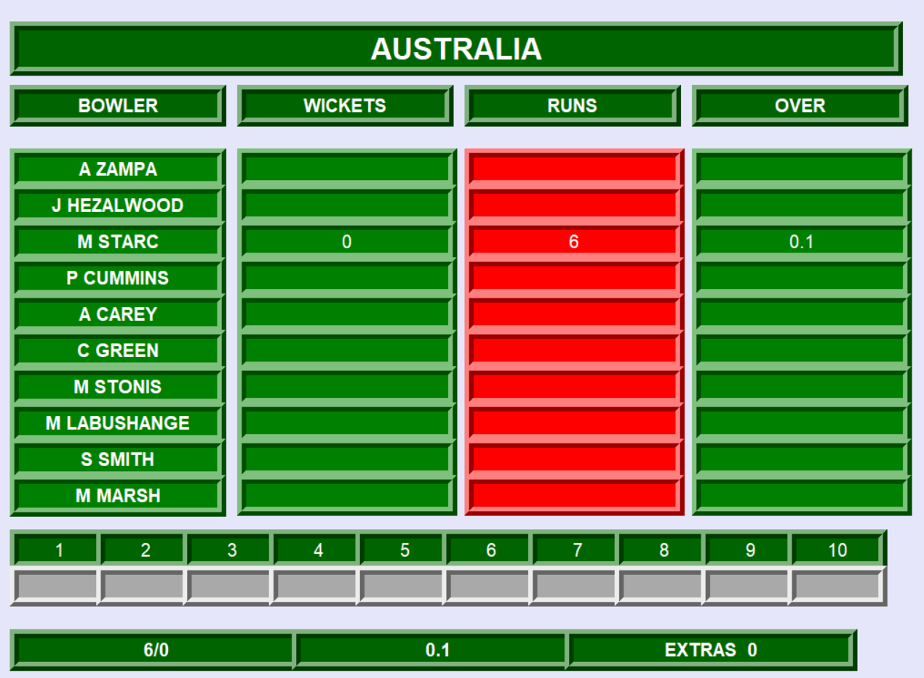
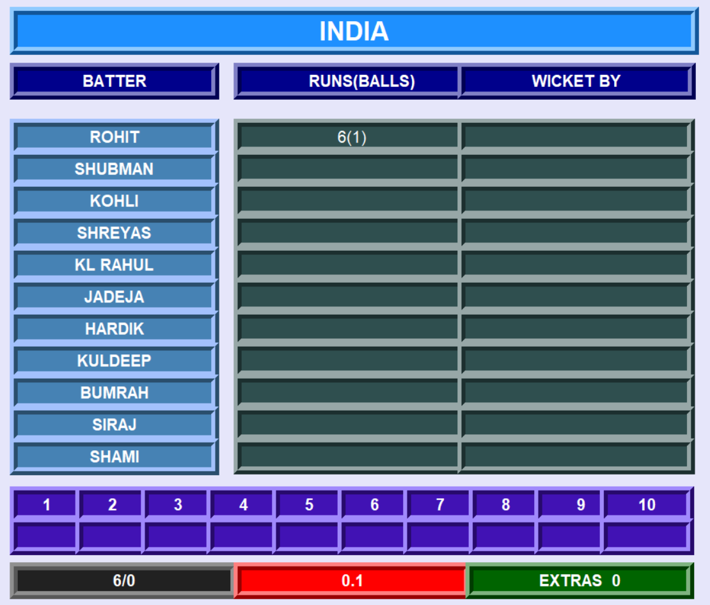

THE SECOND INNING FIRST BOWL DATA SHOWN IN THE BATTERS WINDOW

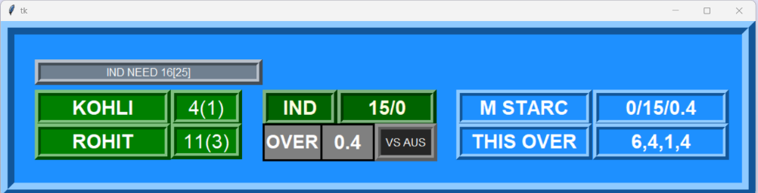
MATCH CONTINUING WITH UPDATES BEING DONE IN ALL WINDOWS
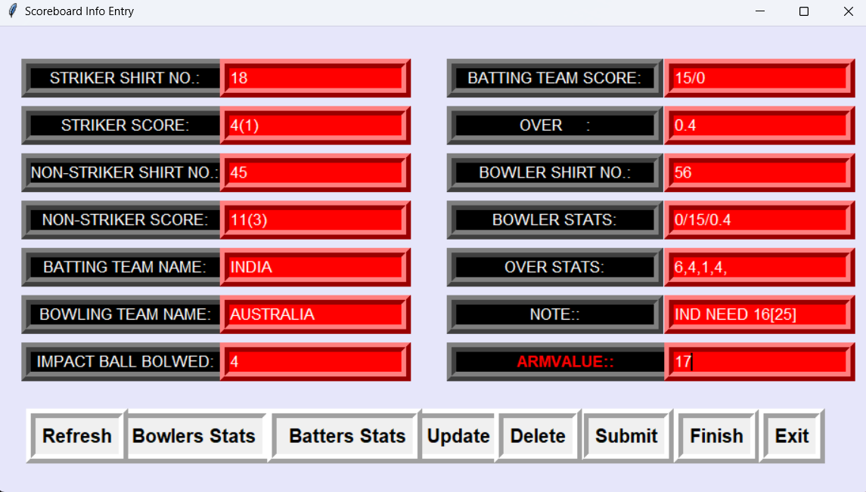

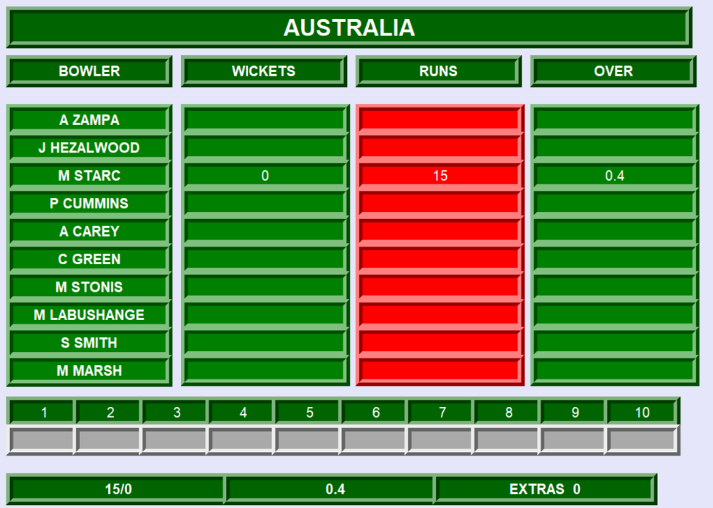

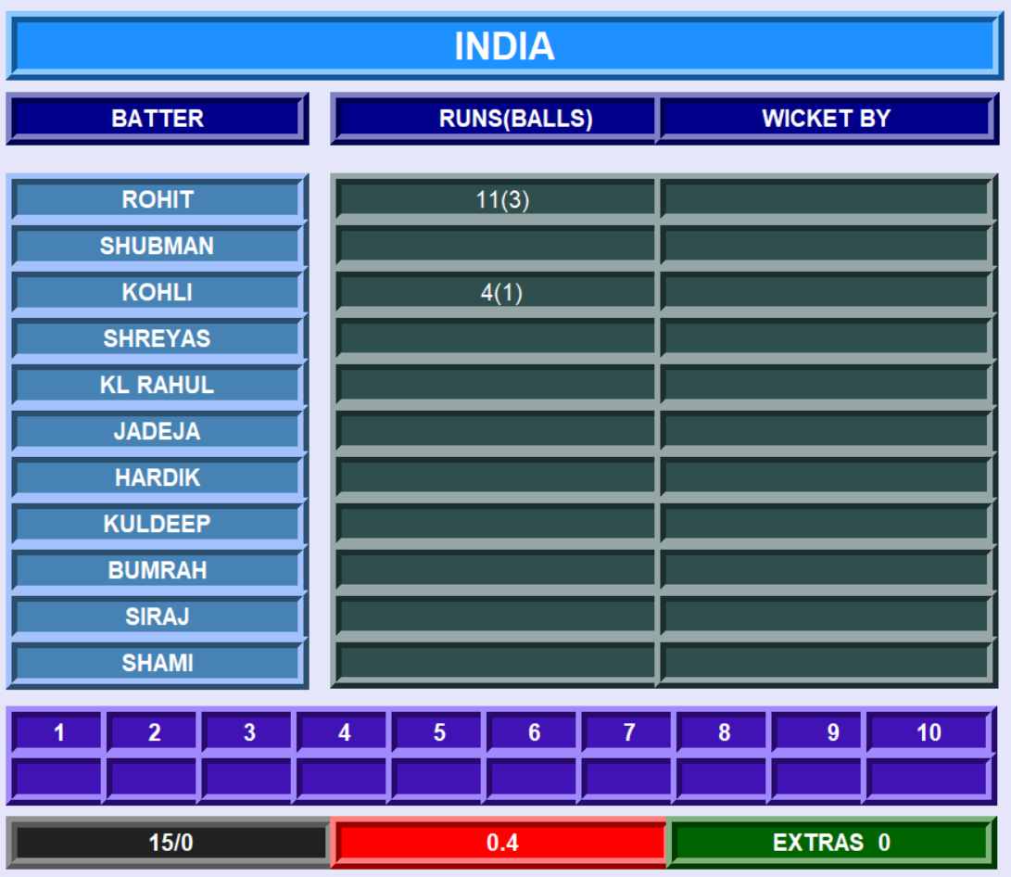

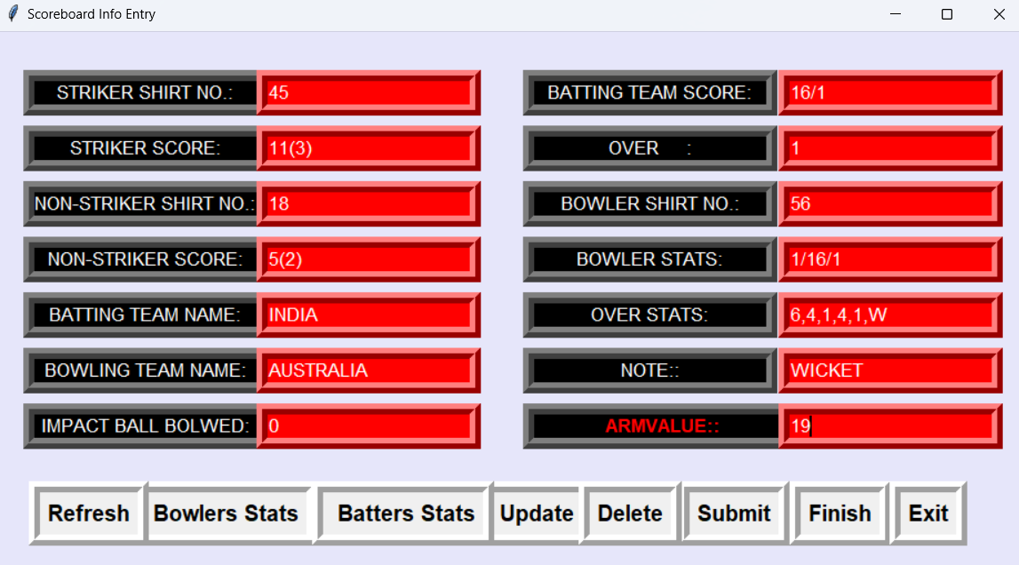
WITH THE NEW OVER, NEW BOWLER, FIRST WICKET IS DOWN, DETAILS ARE ENTERED INTO THE ENTRY WINDOW NOTE SECTION CONTAINS TERM WICKET AND IS BEING REFLECTED IN THE SCOREBOARD STRIP
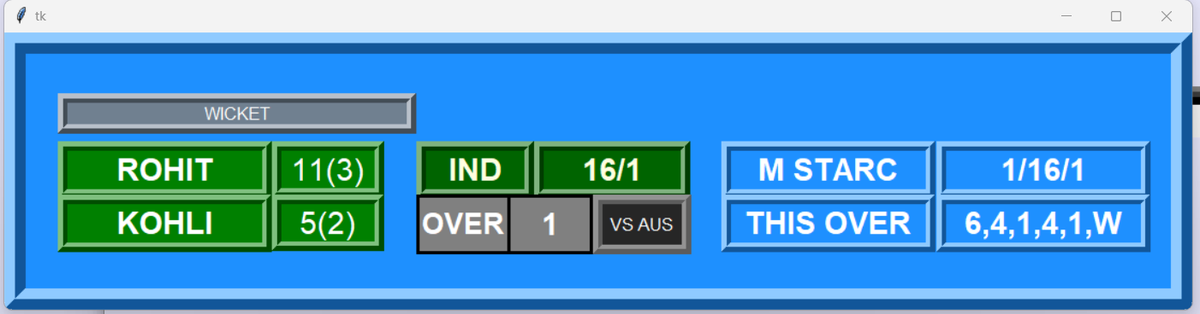
SCOREBOARD STRIP GOT UPDATED WITH WICKET
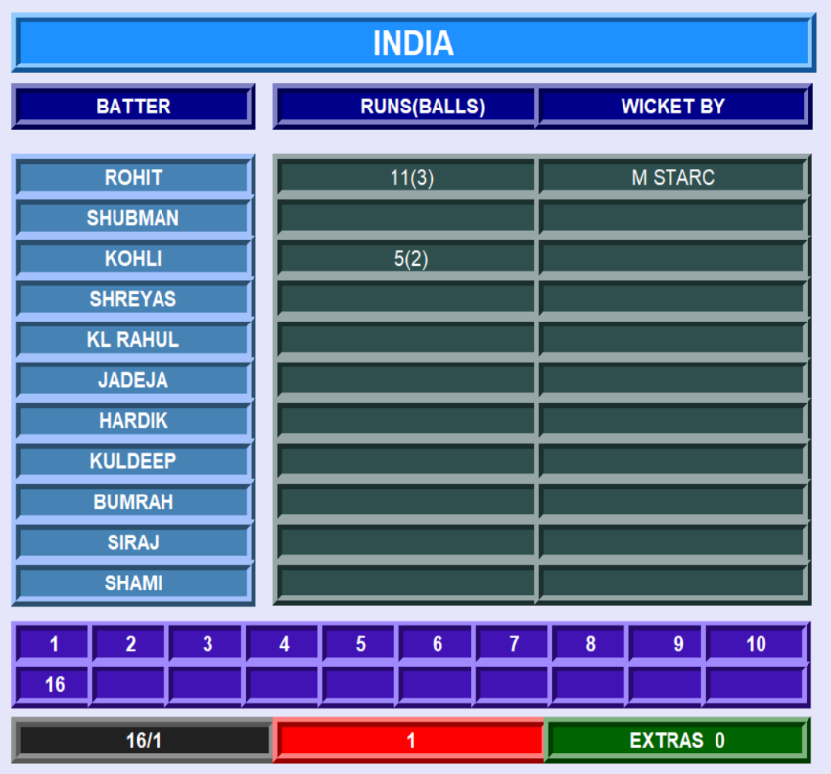

THE BATTER’S WINDOW IS UPDATED WITH WHO TOOK THE WICKET WHOSE WICKET IS DOWN AND ON WHICH RUN THE WICKET FELL OFF

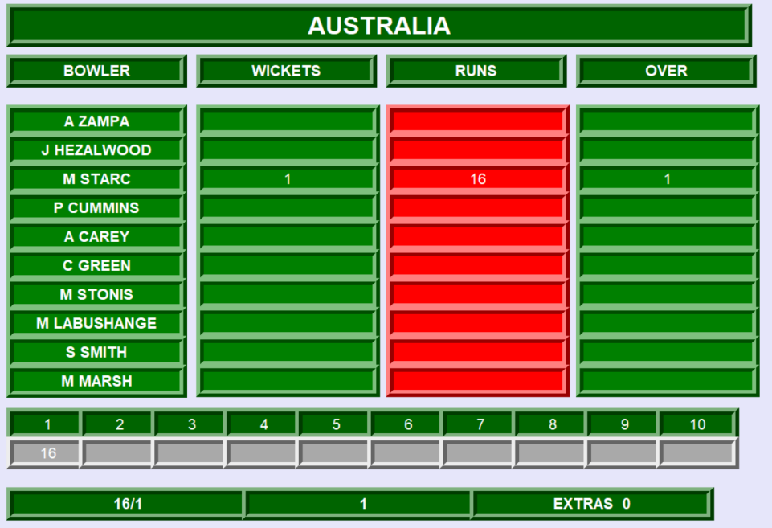
THE BOLWERS WINDOW IS UPDATED WITH WHICH BOLWER TOOK WICKET HIS STATS AND ON WHICH RUN THE WICKET FELL OFF

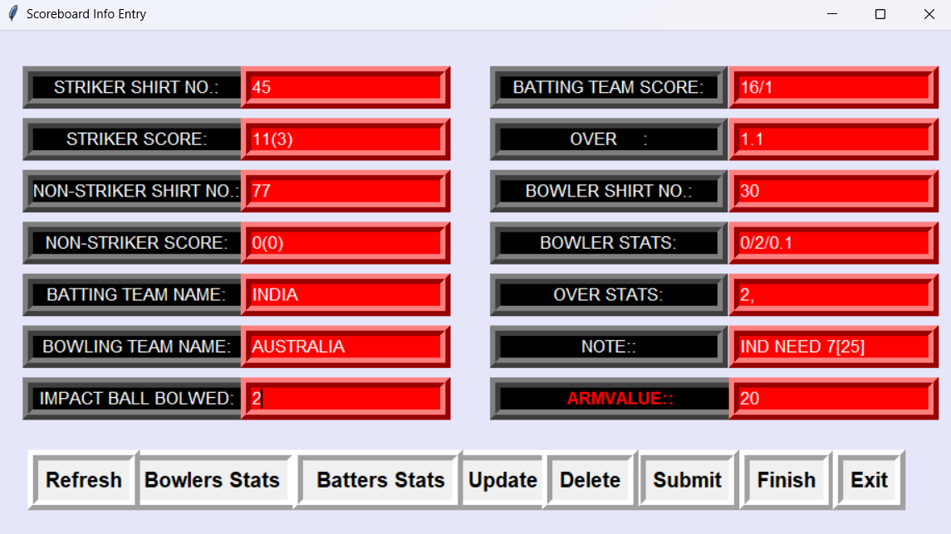
FIRST BOWL OF NEXT OVER IS DELIVERED BY ANOTHER BOLWER AND NEW BATSMEN IS IN
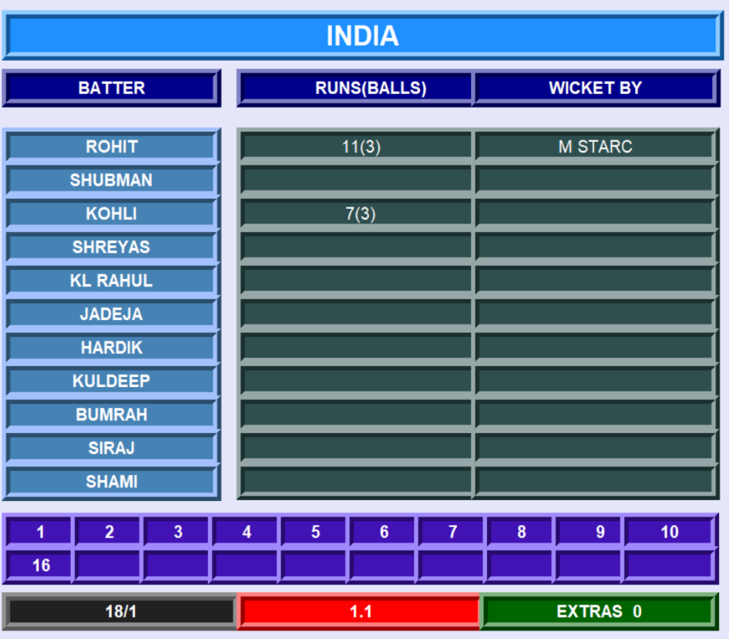
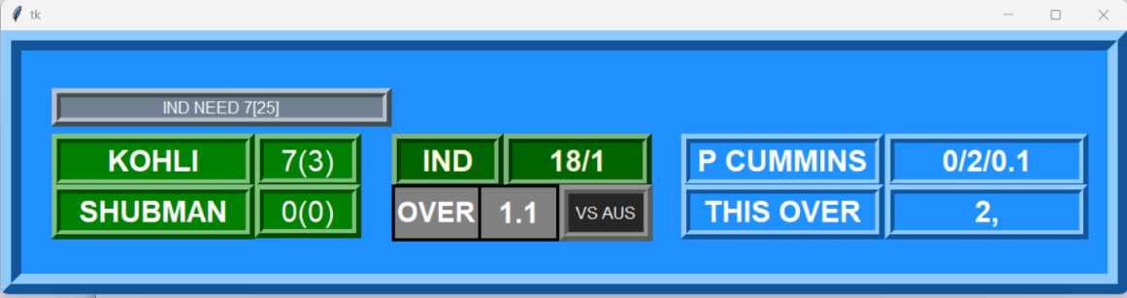
SCOREBOARD STRIP GOT UPDATED WITH NEW BOLWER DETAILS AND NEW BATTER IS IN

UPDATES DONE IN BATTERS WINDOW

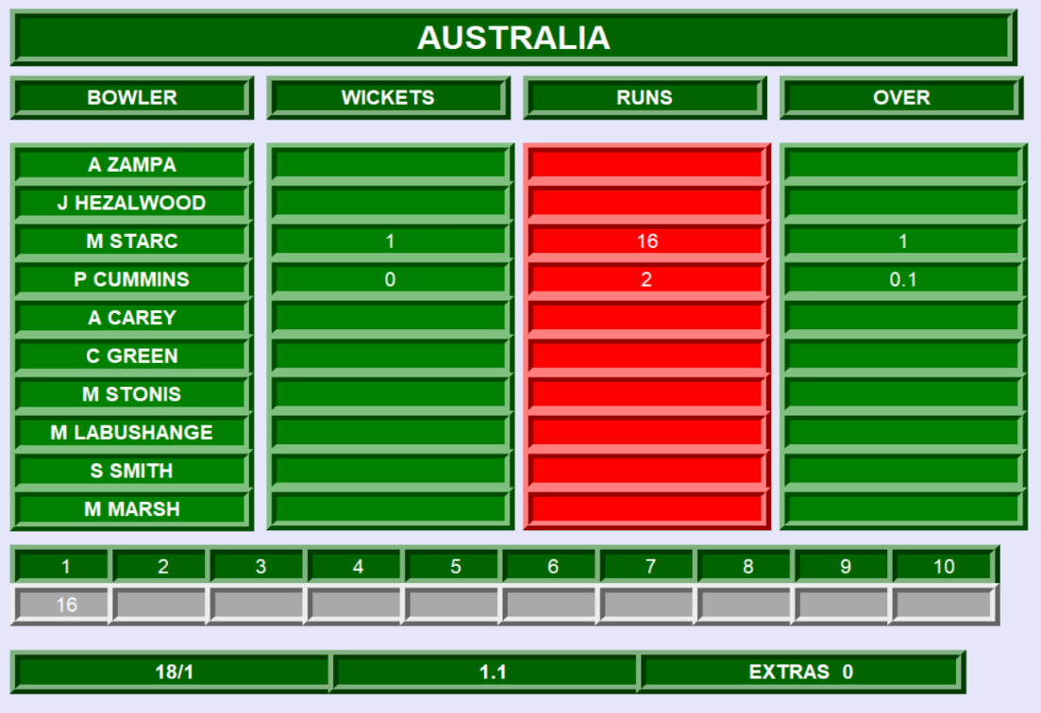
UPDATES DONE IN BOWLERS WINDOW

MATCH CONTINUING, AN EXTRA IS DELIVERED AND MENTIONED IN NOTE ENTRY

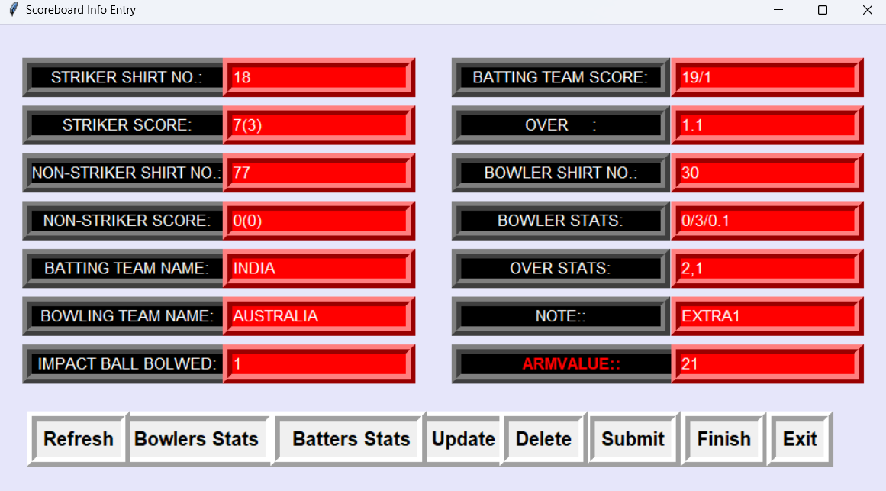

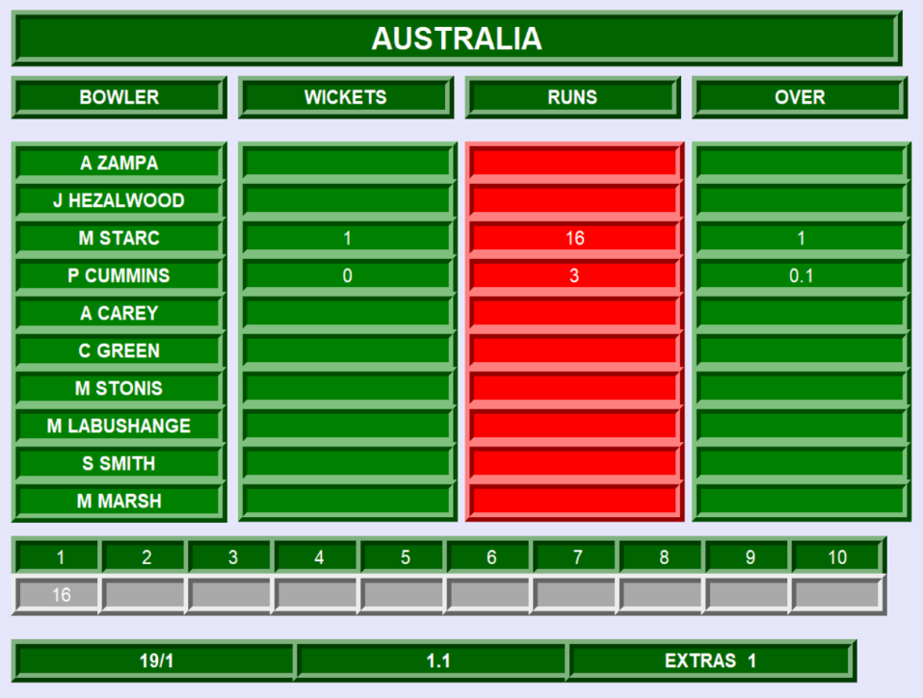
EXTRA 1 RUN DELIVERED ON THE LAST BOWL IS UPDATED IN THE BOLWERS WINDOW

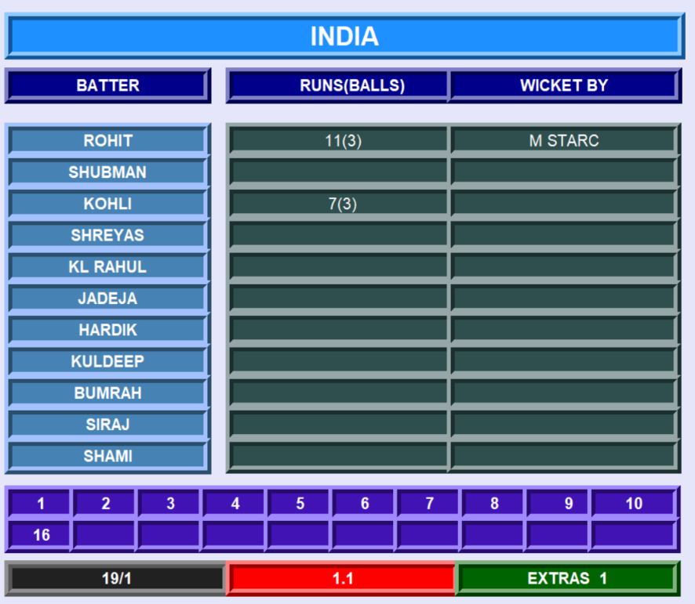

EXTRA 1 RUN DELIVERED ON THE LAST BOWL IS UPDATED IN THE BATTERS WINDOW

INDIA WON BY 9 WICKETS, DETAILS ARE ENTERED AND THIS IS THE LAST ENTRY
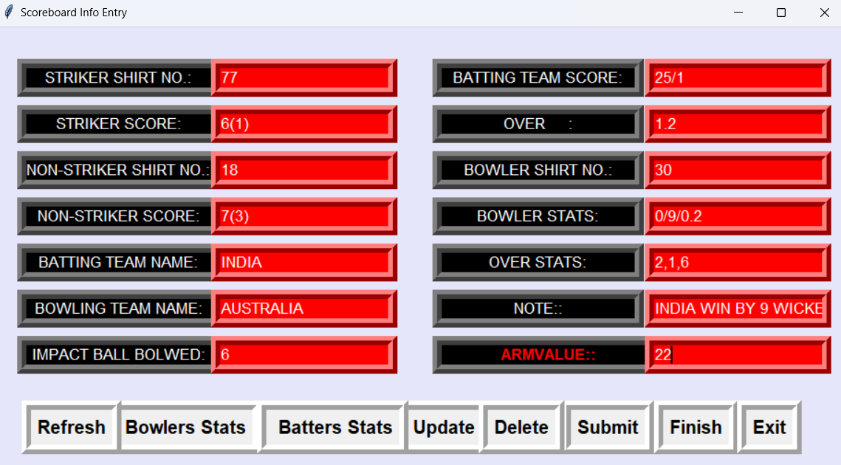
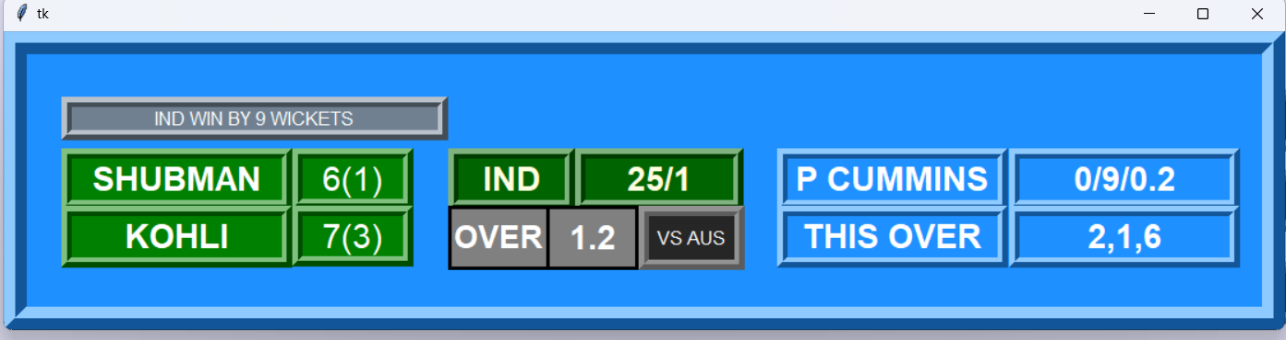
LAST SCOREBOARD STRIP AND TEAM WINS BATTING SECOND

BOWLERS WINDOW UPDATED

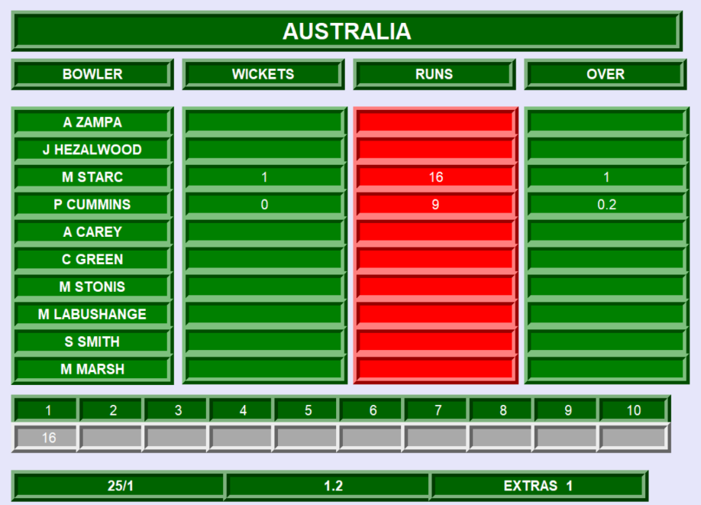

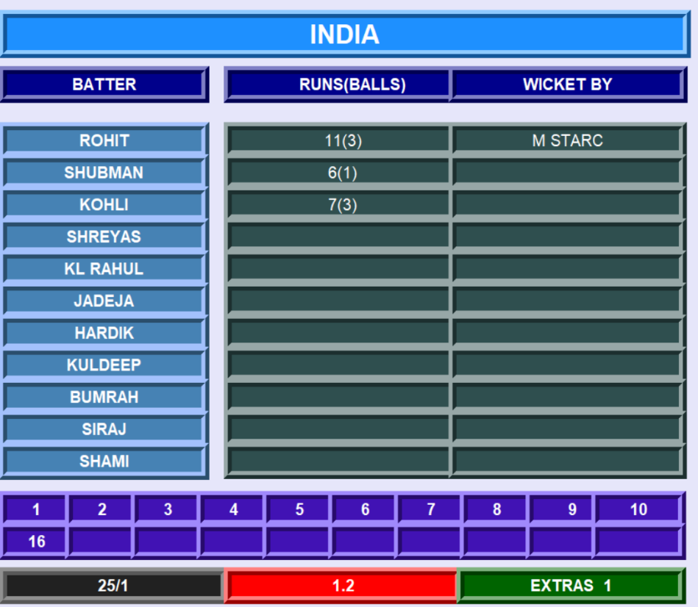

BATTERS WINDOW UPDATED

MATCH FINISHED, CLICKED ON FINISH BUTTON

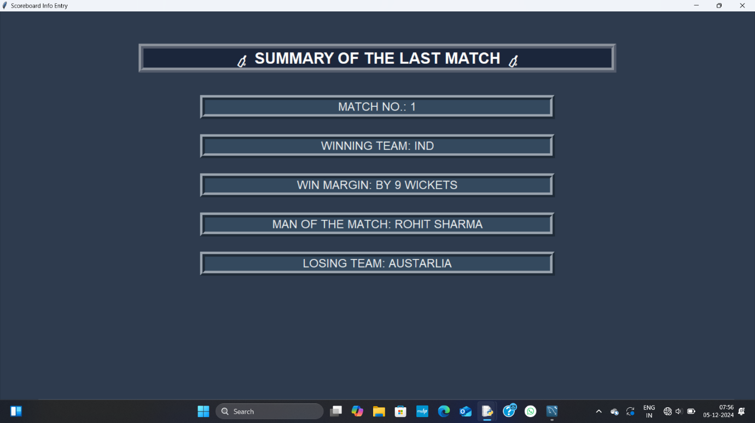
DETAILS ARE BEING ENTERED IN THE FINISH WINDOW AND SUBMITTED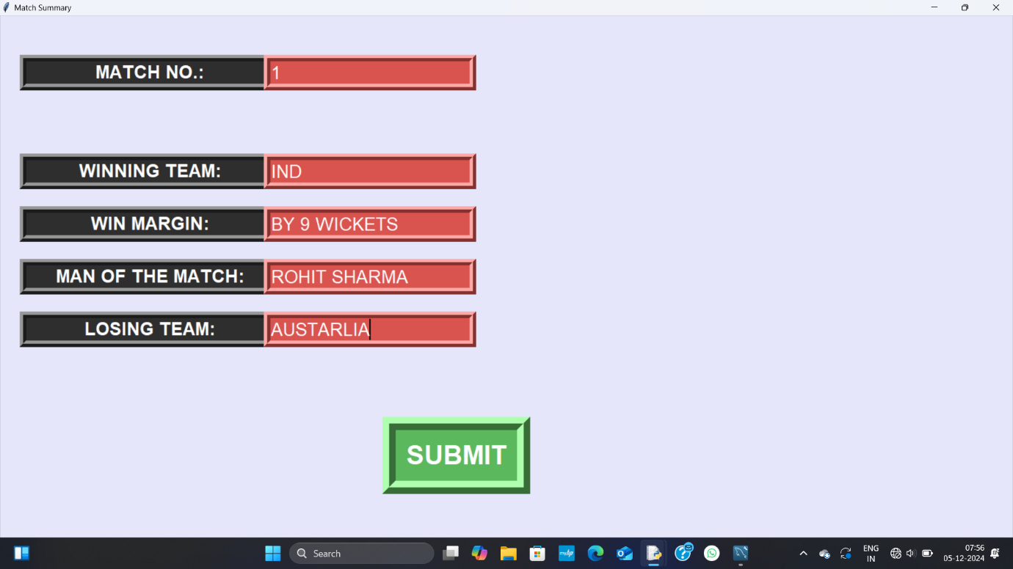

SUBMITTED DETAILS ARE SHOWN

